# Chapter 2: Requirements Specification

## **2.1 Introduction**

The major objective of this chapter is to provide a clear insight of how the current system operates, and how it is to be integrated into the proposed solution. This chapter will cover requirement analysis, data requirements, processing requirements, software requirements as well as hardware requirements. Fact finding is process of collection of data and information based on techniques which contain sampling of existing documents, research, observation, questionnaires, interviews, prototyping and joint requirements planning (Kothari, 2002). System analyst uses suitable fact-finding techniques to study the current existing system. Collecting required facts are very important to apply tools in System Development Life Cycle because tools cannot be used efficiently and effectively without proper extracting from facts (Teka, 2008). Fact-finding techniques are used in the early stage of System Development Life Cycle including system analysis phase, design and post implementation review. Facts included in any information system can be tested based on three steps: data- facts used to create useful information, process-functions to perform the objectives and interface-designs to interact with users.

Fact-Finding often brings systems analysts into contact with working procedures of the current system. Effective fact*-*finding techniques are crucial to the developmentof systemsprojects. Data was collected through use of questionnaires, interviews, observation and document review with the aim of collecting reliable and complete data that can provide concrete conclusions and recommendations for the study.

## **2.2 Requirements analysis**

### **2.2.1 Questionnaire for system users**

Questionnaires present written questions to respondents, who in turn provide their answers in small written words or ticks to represent a selected choice. The researcher gave questionnaires to the sales people and supervisors and manager sample after they had participated in the research. Two sets of questionnaires were used in this research, one responded by storekeepers and the other was responded by the supervisors and manager. Questionnaires were used as data gathering tools because they are practical and large amounts of information can be collected from large number of people within a short period of time and results from questionnaires can be quickly and easily quantified by the researcher. Questionnaires were used as data gathering tools because they are practical and large amounts of information can be collected from large number of people within a short period of time and results from questionnaires can be quickly and easily quantified by the researcher.

### **2.2.2 Interview Questions for system users**

Interviews were held mainly with students as the administration staff members were busy most of the time. The interviews were semi structured so as to guide the flow of the interview so that only the required information was gathered. The students and Teachers who are the mainly affected with the manual method of feedback at Queen Elizabeth High School provided in-depth and comprehensive information about the situation. The researcher used qualitative skills to sum up and quantify the responses obtained from the interviews. The interviews had open ended questions so as to get the actual feelings and ideas being experienced.

### **2.2.3 Observations for system users**

Participatory observation was also used to collect research information. Participating Observation was used because it enabled the researcher to gather nonverbal expression of feelings and to check on the amount of time spent on various administration reading all evaluated form for every student and calculate percentage of each teacher according to students’ evaluation. In simple terms, participant observation was used because it increases the validity of research, and this helped the researcher to understand the context and phenomenon under study. The researcher observed the time taken by each administration to go through every form evaluated by each student. The overall time taken to evaluate teacher and calculate total percentage was observed. This was compared to the time taken to evaluate using Feedback System

**2.3 Data requirement**

**Input**

**Student Details**

The form below shows Student input field. The student will fill in the required details and submit. This form will validate correct data inputted before submit to the database.

First Name

Surname

Phone

Password

Gender

Date of Birth

Email Address

Address

Reg Number

## **Teacher registration**

First Name

Surname

Phone

Department

Gender

Subject

Email Address

EC Number

Address

## **Feedback Form**

Comm Skills

Behavior

Teaching Aids

Presentation Skill

Voice Projection

Punctuality

Revision Test

Exercise Work

Attitude

## **2.4 Processing requirement**

### **2.4.1 Functional Requirements**

These requirements specify what the system is supposed to do:

* The system must be easy to use for the personnel.
* Allow user to log on to the system with a data integrity maintained.
* The system should be designed with flexibility, which, whilst ensuring controls are maintained, will facilitate enhancement being implemented within reasonable time scales and cost levels, to accommodate internal and external changes.
* All data captured must be retained and be readily accessible, when required, for manipulation into effective management information for example.
* To be stored in the database.
* The system should enable data to be captured only, at the earliest possible business stage, during business stages if necessary and used thereafter in subsequent processes to ensure data consistency.
* The system should enable owners to update the status of the teacher information
* The system should also enable the Administrator to view results of each teacher evaluated

### **2.4.2. Non-Functional Requirements**

Constraints associated with the development of the system include:

* The system should respond to queries presented to it by the end-users.
* The database should not be vulnerable to the end-users. It should not be accessible to them at all. Therefore there should be an operating environment for system developers and an operating environment for system users.
* The system should allow for use of password security. Only authorized and authenticated users should have access to the system.
* Each individual should have a unique sign-on, which should designate the level of access required.
  + Client level
  + Administrator levels (add, change, delete).
  + Application level.
* The system should allow for alterations to be made easily to its capabilities.
* The system should make use of user familiar terms.
* The system should be consistent in its operation.
* The system user interface should provide a meaningful feedback when errors occur and provide content sensitive user help facilities.
* The interface should provide appropriate interaction facilities from different types of system users.
* The system should be portable, such that, it should be able to provide the same functionality under a different set of the organization’s hardware or operating system.
* Emphasis should also be placed on the reliability and availability of the system – Management and the project supervisors needed the system to be operational 95% of the time.

### **2.4.3 Use Case Diagram**

Use case diagram consists of use cases and actors and shows the Interaction between the use cases and actors. Use cases are the function that are to be performed in the module. An actor could be the end user of the system or the external system.

**Use Case Diagram for Admin**

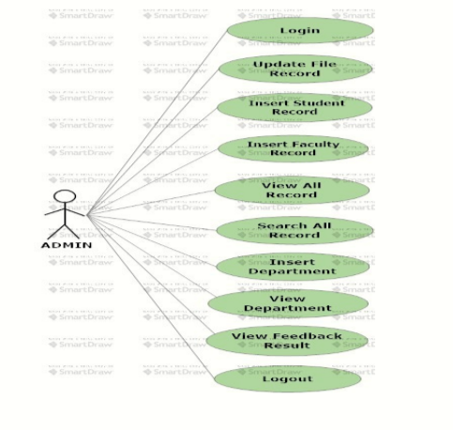

### **2.4.4 Activity diagram**

Activity diagram is another important diagram in UML to describe dynamic aspects of the system. Activity diagram is basically a flow chart to represent the flow form one activity to another activity. The activity can be described as an operation of the system. So the control flow is drawn from one operation to another. This flow can be sequential, branched or concurrent.

**Activity diagram for Student**

Login

YES

NO

Valid Username and Password

Give Feedback

Logout

Invalid Username and Password

Error Message

**Activity diagram for Administrator**

Logout

Login

YES

NO

Valid Username and Password

Invalid Username and Password

Error Message

isLogged

View Feedback

Update Teacher Profile

**Class Diagram for Feedback System**

## **2.5 Software requirement**

* Visual Studio
* MySQL
* C#.NET
* Wamp server

## **2.6 Hardware requirement**

* Processor: Dual core
* RAM: 512 mb
* Memory: 10 GB